
Children’s

Singing Week

Does your child love to sing? Let your child improve his/her musical skills and memory through group singing. Our 5 – 7 yr old students will learn developmentally appropriate songs through echo singing. Students 8 – 9 yrs old will begin to learn songs from scores. Those who are interested may get a chance to sing solo.
No ability to read musical score necessary. Minimum: 6 kids/session

Sessions:
10:45 - 11:45 AM (5 - 7 year olds)
NOON – 1:00 PM (7 - 9 year olds)*
*must be able to read & follow along with song texts

Dec. 29th – Jan 2nd

Combined Final Performance on Friday 12:30 – 1:00 PM
For samples of last summer’s singing week check out www.karenamlaw.com/SummerSingingWeekAll.html

Cost: $90 Instructor: Karen Amlaw
Super Deal: $75/session if attending both Kids on Keys and Singing Week.

Children’s

Saturday Sings
Similar format to singing week
Saturday afternoons
in Spring 2009

Combined Final Performance as part of
Spring 2009 Young Musician’s Recital Series

Cost: TBA based on an 8-week enrollment
Instructor: Karen Amlaw

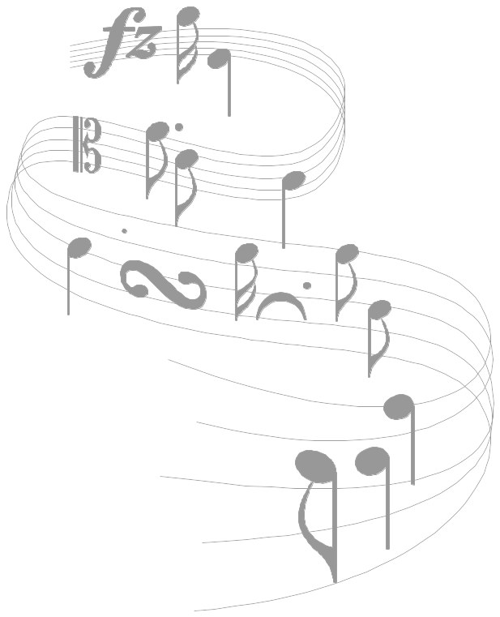

Young

Musicians’
Recital Series

Featuring students

from

the studio of

Karen Amlaw

Kids on Keys
Program Director

Friday, November 14th, 2008 – 6:15 PM

Sunday, November 16th, 2008
2 PM, 3:45 PM & 5:30 PM

Robinson Music Inc.
Westborough, Massachusetts

Friday – 6:15 PM

Bobby Rodolakis Main Theme from Star Wars
(Williams / arr. Barden)

Emily Wu Figure Skating (Alfred)

Anisha Kundu Ode to Joy (Beethoven / arr. McTaggart)

Megan Loeffel Trolley Song (Alfred)

Acacia Truong Up to the Moon (Alfred)

Sequoia Truong Row, Row, Row Your Boat (Alfred)

Eliza Rubin Ode to Joy (Beethoven / arr. McTaggart)

Bryana Siquiera The Howling Wind (Alfred)

Sachin Pauluri The Baseball Game (Alfred)

Michelle W. Nie Ode to Joy (Beethoven / arr. Bastien)

Ray Xu Morning Mood (Grieg / arr. Bastien)
Theme from Pastoral Symphony No. 6
(Beethoven / arr. Bastien)

Claire Duffy Barcarolle from “Tales of Hoffman”
(Offenbach / arr. Bastien)
Rudolph the Red-Nosed Reindeer
(Marks / arr. Faber & Faber)

Members of Kids on Keys Goodbye Song (Barden)

Special Thanks to
Family and friends
for supporting these students’ musical efforts.

Sunday – 5:30 PM

Lawrence Tang Ode to Joy (Beethoven / arr. McTaggart)

Grace Ye Row, Row, Row Your Boat (Alfred)

Eric Justin Mickey Mouse March
(Dodd / arr. Faber & Faber)

Adhit Thakur Figure Skating (Alfred)

Cole Lippert Mary Had a Little Lamb
(folk song / arr. McTaggart)

Mateo Oyola Where Did You Get That Hat? (Alfred)

Ian Anderson The Fish Won’t Bite (Alfred)

Arjun Puri If I Won a Million Dollars (Alfred)

Shayla Walsh The Howling Wind (Alfred)

Jerry Shu Three Wise Monkeys (Alfred)

Adway Wadekar The Jack O’Lantern Song (arr. Miss Karen)

Alana Carlucci Music with a Beat (Alfred)
Für Ludwig (Alfred)

Adway Wadekar Jolly Old Saint Nicholas (arr. Alfred)

Alana Carlucci Deck the Halls (arr. Bastien)

Nidhi Pednekar A Prayer for Peace (Alfred)

Members of Kids on Keys Goodbye Song (Barden)
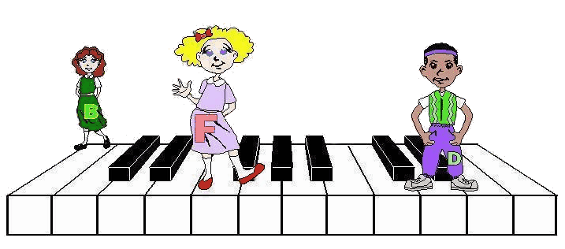

Sunday – 3:45 PM

Jane Curley Row, Row, Row Your Boat (Alfred)

Henry Wong Mary Had a Little Lamb
(folk song / arr. McTaggart)

Joseph Levins Hot Cross Buns (folk song)

William Hanson Rain, Rain Go Away (trad. children’s song)

Harshitha Narahari Figure Skating (Alfred)

Dora Chen Ode to Joy (Beethoven / arr. McTaggart)

Jack Napoleone Up to the Moon (Alfred)

Zack Blair Rain, Rain Go Away (trad. children’s song)

Raghu Kommalapaty Old Woman (Alfred)

Katelyn Firth Theme from Tchaikowsky’s 4th Symphony
(Alfred)
Jingle Bells (Pierport / arr. Alfred)

Julian Wagner A Prayer for Peace (Alfred)

Members of Kids on Keys Goodbye Song (Barden)

Where You Can Find The Pieces Heard in These Recitals:

* McTaggart arrangements are part of the Kids on Keys Workbook Series.
* Alfred arrangements are from the Level 1A & 1B Fun Books of Alfred’s Basic
Piano Library.
* Bastien arrangements are from Levels 1 and 2 of Bastien Piano Library’s
Favorite Classic Melodies Series.
* Faber & Faber arrangements are from the PreTime Piano – Children’s Songs
collection.
* The Star Wars Theme arranged by Barden is part of Alfred’s My First Pop
Songs Collection.

Sunday – 2 PM

Danielle Heims Mary Had a Little Lamb
(folk song / arr. McTaggart)

Kate Duval Ode to Joy (Beethoven / arr. McTaggart)

Diya Mathew Trolley Song (Alfred)

Aksel Reid Hot Cross Buns (folk song)

Sophia Brady Mary Had a Little Lamb
(folk song / arr. McTaggart)

Ryan Gilmartin Happy Birthday (Faber & Faber)

Geethika Bathini Figure Skating (Alfred)

Caroline Davis Trolley Song (Alfred)

Kaitlyn Desio Mary Had a Little Lamb
(folk song / arr. McTaggart)

Victor Verma Theme from Tchaikowsky’s 4th Symphony
(Alfred)

Kyra Lee The Howling Wind (Alfred)

Stephanie Wong The Fish Won’t Bite (Alfred)

Gowtham Manickam Music with a Beat (Alfred)

Harrison Vogt Für Ludwig (Alfred)

Members of Kids on Keys Goodbye Song (Barden)

