Sunday - 4 PM
Trevor Leong Hot Cross Buns (folk song)
(student of Karen Amlaw)

Jenna Merendino Mary Had a Little Lamb (folk song)
(student of Karen Amlaw)

Toby Jiganti Up to the Moon! (Alfred*)
(student of Karen Amlaw)

Pranav Masson Mary Had a Little Lamb (folk song)
(student of Karen Amlaw)

Zoe Foster Lightly Row (folk song)
(student of Peter Hughes) Twinkle, Twinkle Little Star (folk song)

Shayla Walsh Biking (Alfred*)
(student of Karen Amlaw)

Hardee Bhavsai Hot Cross Buns (folk song)
(student of Karen Amlaw)

Sara Stec Mary Had a Little Lamb (folk song)
(student of Karen Amlaw)

Madison Lehr Rock Along! (Alfred*)
(student of Karen Amlaw)

Shayla Walsh Twinkle, Twinkle Little Star (folk song)
(student of Peter Hughes)

Maia Modjahedpour Go Tell Aunt Rhody (folk song)
(student of Peter Hughes) Allegro (Suzuki)

Anthony Sung Gliding (Alfred*)
(student of Karen Amlaw)

Timothy Palczynski Happy Birthday (Faber & Faber**)
(student of Karen Amlaw)

Snigdam Majumder Crackerjack (Alfred*)
(student of Karen Amlaw)

Harry Cho Gavotte (Lully)
(student of Peter Hughes)

Nidhi Pednekar Where Did You Get that Hat? (Alfred*)
(student of Karen Amlaw)

Julian Wagner Winnie the Pooh (Faber & Faber**)
(student of Karen Amlaw)

Shrirang Sane The Fish Won’t Bite (Alfred*)
(student of Karen Amlaw) Bingo (Faber & Faber**)

Members of Kids on Keys Goodbye Song (Barden)

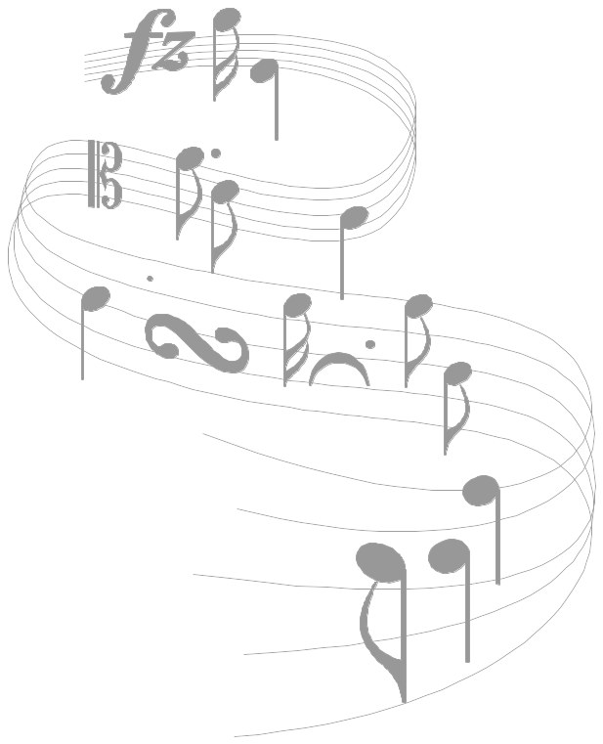

Young

Musicians’
Recital Series

Featuring students from the studios of
Karen Amlaw (Kids on Keys)
Peter Hughes (Violin)

Friday, Nov. 16th, 2007 – 5:45 PM

Sunday, Nov. 18th, 2007
2 PM & 4 PM

Robinson Music Inc.
Westborough, Massachusetts

Friday - 5:45 PM
(Students of Karen Amlaw)

Alex Zhang Mary Had a Little Lamb (folk song)

Kyra Lee Figure Skating (Alfred*)

Erin Duffy Trolley Song (Alfred*)

Elise Descheneaux Mary Had a Little Lamb (folk song)

Andrew Chen Figure Skating (Alfred*)

Elia Knaf Ode to Joy (Kids On Keys/Beethoven)

Ava Knaf Row, Row, Row Your Boat
(variation on a folk song –Alfred *)

Michelle W. Nie Mary Had a Little Lamb (folk song)

Harrison Vogt What Will You Do? (Alfred*)

Garrett Sullivan If I Had A Pony (Alfred*)

Members of Kids on Keys Goodbye Song (Barden)

* These songs are part of the collection of piano pieces found in the Level 1A Fun Book and Recital Books of Alfred’s Basic Piano Library.

** These songs are part of the collection of piano pieces found in the PreTime Piano - Children’s Songs Book arranged by Faber & Faber

See our special section for holiday books in these same series, as well as others you child may enjoy.

A Special Thanks to

Parents and friends
for supporting these students’ musical efforts.

Dennis Deyo for accompanying Erin Chen

Shirley and Jennifer Amlaw for donating flowers.

Sunday - 2 PM
Michael Kurlan Mary Had a Little Lamb (folk song)
(student of Karen Amlaw)

Brian Chen Gavotte (Lully)
(student of Peter Hughes)

Erin Chen Minuet (Boccherini)
(student of Peter Hughes)

Caitlin Maria On a Funny, Sunny Day (Alfred*)
(student of Karen Amlaw)

Shannon Maria Row, Row, Row Your Boat (folk song)
(student of Karen Amlaw)

Aurora Koren Allegretto (Suzuki)
(student of Peter Hughes) Andantino (Suzuki)

Kaitlyn Holly Mary Had a Little Lamb (folk song)
(student of Karen Amlaw)

Claire Duffy Trolley Song (Alfred*)
(student of Karen Amlaw)

William Frank Long, Long Ago (folk song)
(student of Peter Hughes)

Raghu Kommalapaty Mary Had a Little Lamb (folk song) (student of Karen Amlaw)

Katelyn Firth Rockin’ & Rollin’ (Alfred*)
(student of Karen Amlaw)

Arpita Joyce Song of the Wind
(student of Peter Hughes) Go Tell Aunt Rhody (folk song)

Colin Hartnett Circus Day! (Alfred*)
(student of Karen Amlaw)

Bryana Siqueira Row, Row, Row Your Boat
(student of Karen Amlaw) (variation on a folk song –Alfred *)

Apoorva Indraghanty Allegretto (Suzuki)
(student of Peter Hughes) Andantino (Suzuki)

Krithi Krishna Train Song (Faber & Faber**)
(student of Karen Amlaw)

Olivia Crosby Ode to Joy (Kids On Keys/Beethoven)
(student of Karen Amlaw)

Kelcey Dilling On a Funny, Sunny Day (Alfred*)
(student of Karen Amlaw)

Members of Kids on Keys Goodbye Song (Barden)

